Upcoming Workday

When: SATURDAY 2/13/21 Time: 10AM – 1PM
Estimated workday Mid-February. Dependent on weather.
Where: Crain Memorial Park.
Directions: State Highway 70 > Concow Rd. > Jeffrey Pine Lane
Who: Anyone is welcome. Show up ready to work and get your hands dirty!
Why: Come out to help clean up and make your local park beautiful. It can always use some love and attention….. after all it is a gem that survived the fire. Let’s keep it clean, healthy, and fire safe for everyone to use.
Bring:
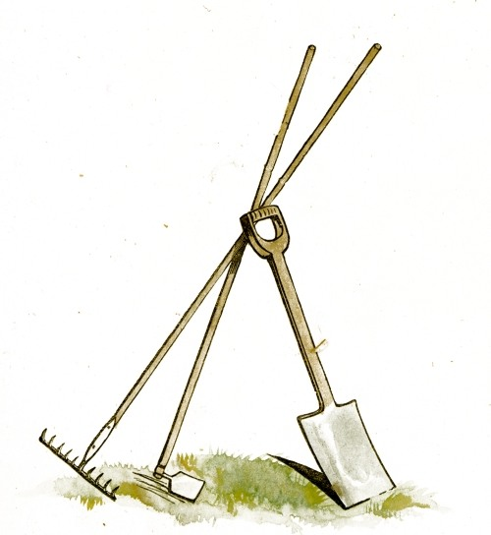
- Water bottle
- Personal work gloves
- Close toed shoes
- Long sleeve shirt/pants
- Safety gear provided: Gloves, safety glasses, hard hat, safety vest.

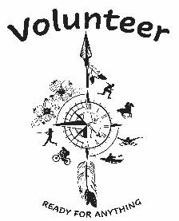

To sign-up or contact for more information:
Volunteer Coordinator: (530) 872 – 6393 or Smunoz-oliverez@paradiseprpd.com

For Volunteering

