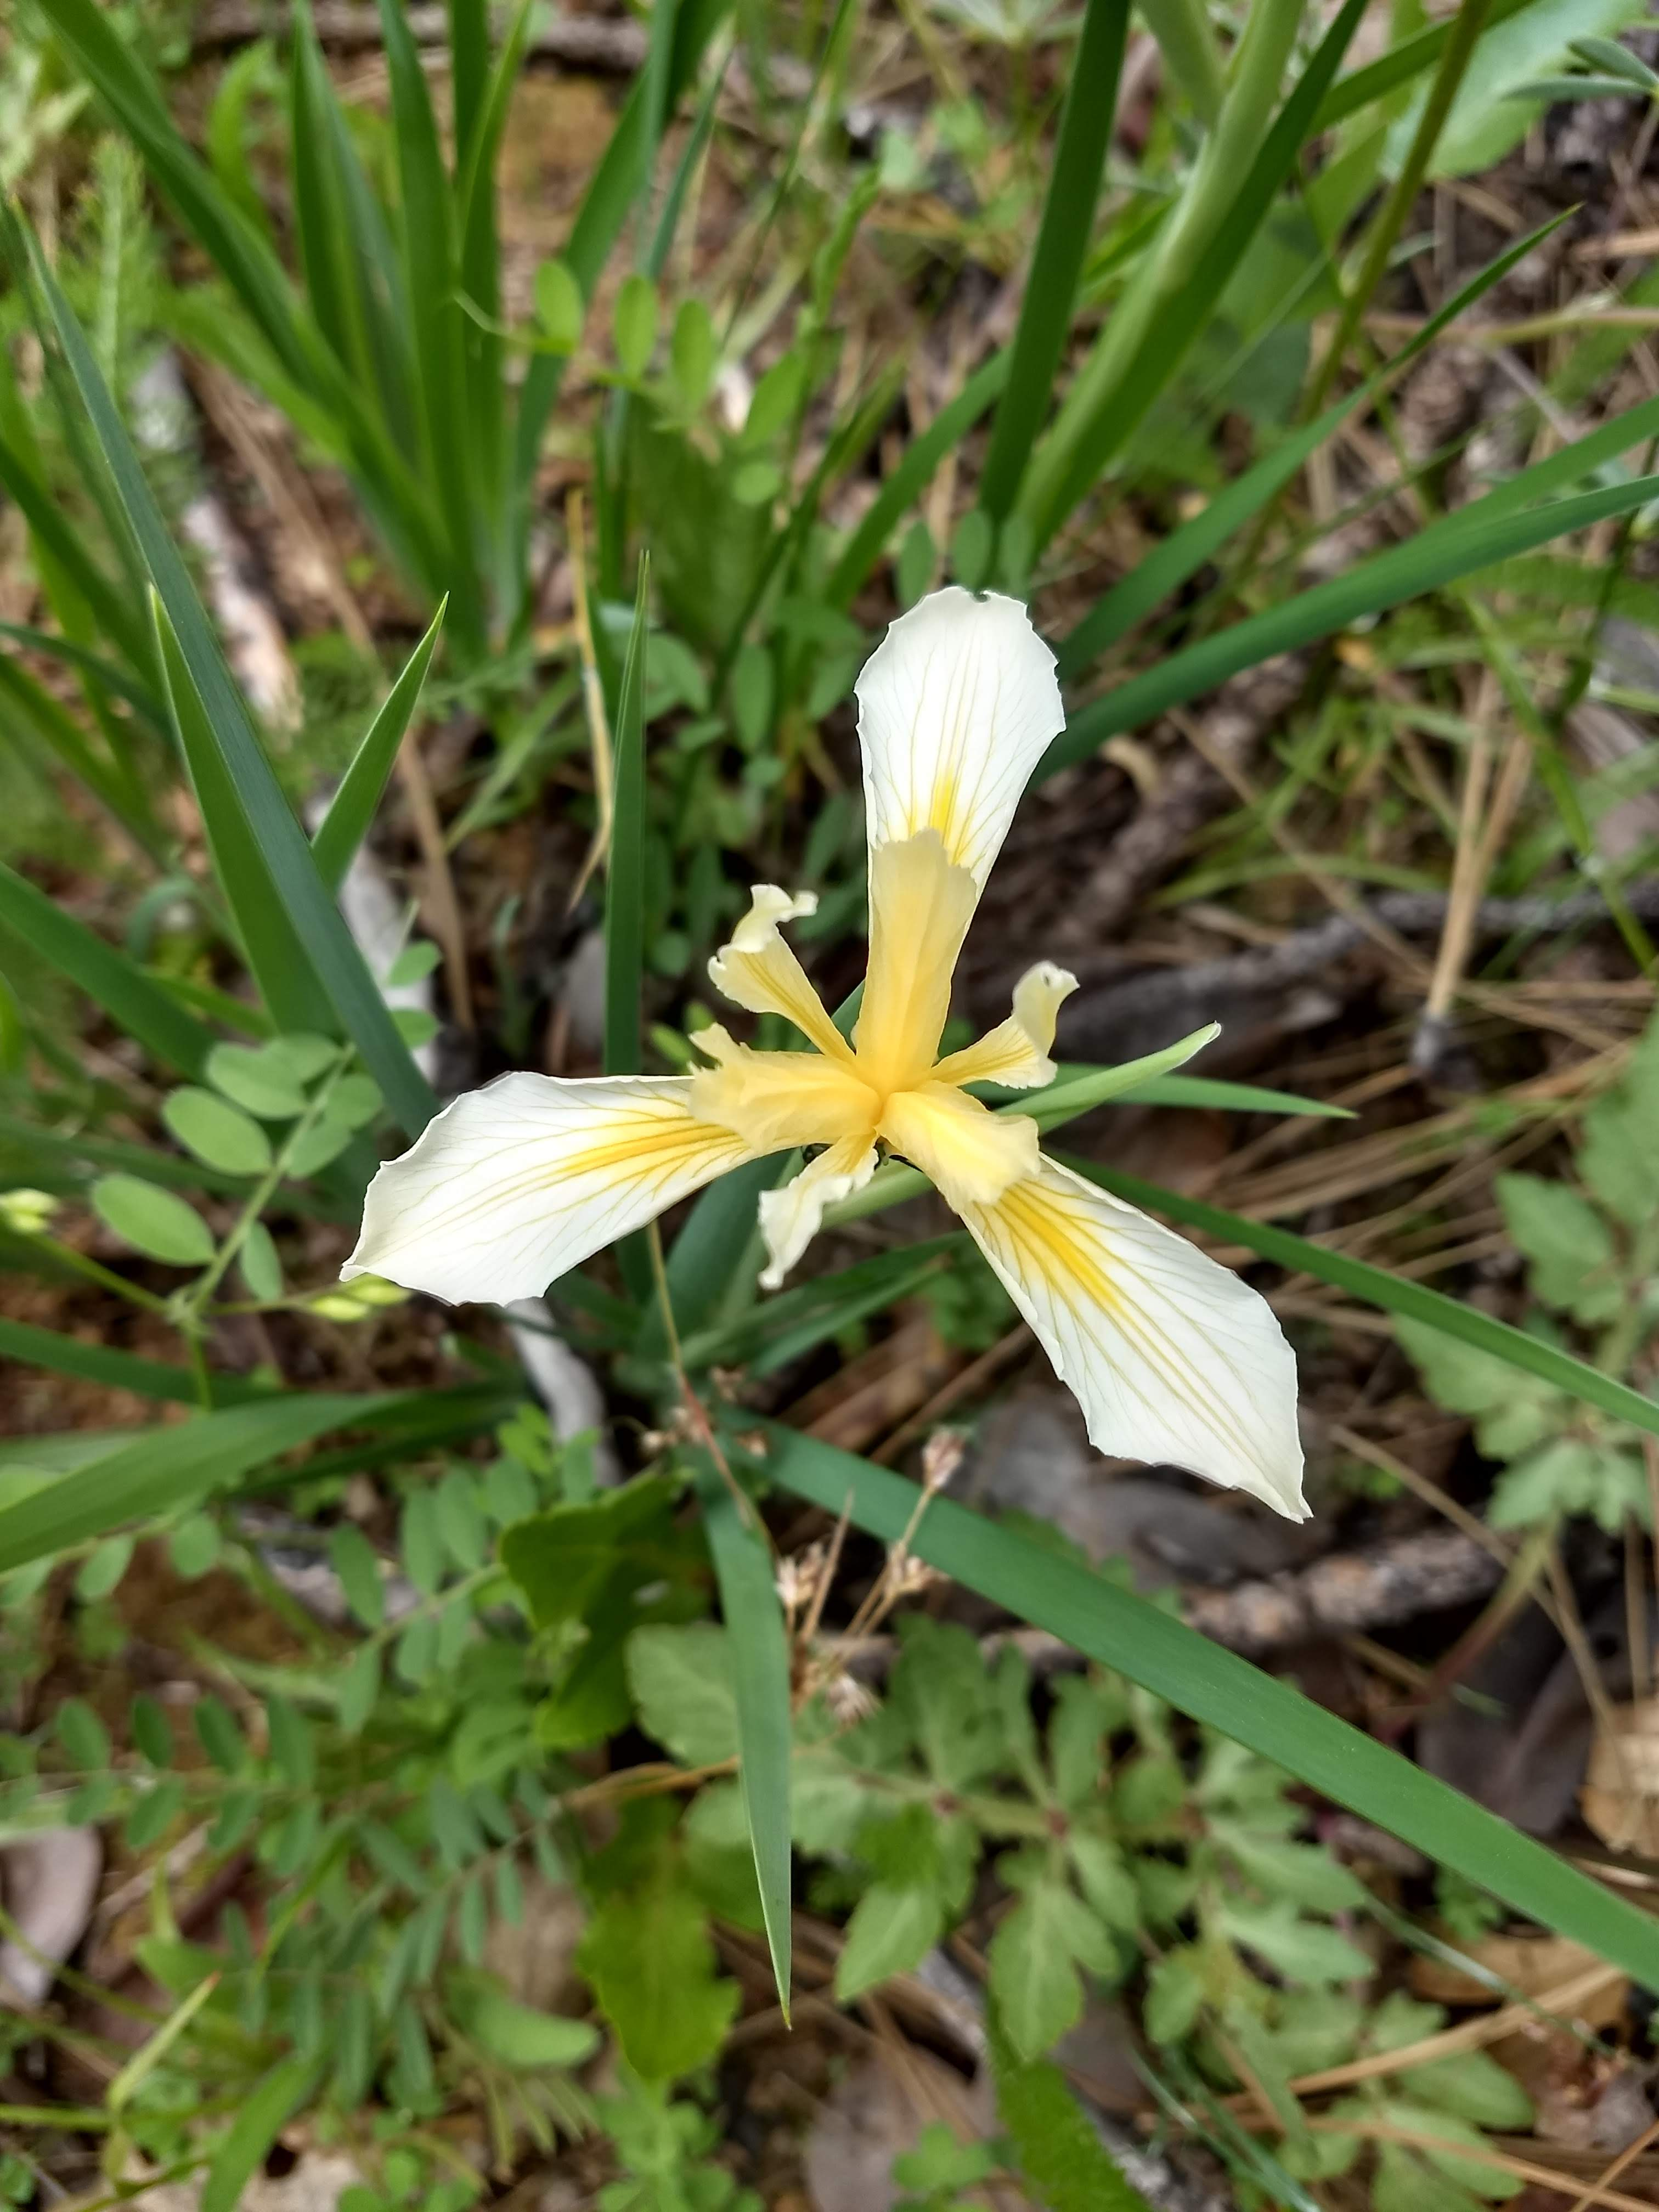

**Paradise Recreation and Park District**

**2019-2020**

**Budget and Financial Report**

**Board of Directors**

Mary Bellefeuille Chairperson

Al McGreehan Vice Chairperson

Robert Anderson Secretary

Steve Rodowick Director

Julie Van Roekel Director

Dan Efseaff District Manager

Table of Contents

I. Budget Overview 1

A. Introduction 1

B. Budget Calendar and Process 1

C. Budget Analysis and Financial Outlook 2

D. Changes from preliminary budget 5

E. Recommendations 5

II. 2019-20 Budget 7

III. Fixed Assets and Capital Improvement Projects (CIP) 14

IV. Funds 31

A. Accumulative Capital Outlay 31

B. General Reserve 32

C. Designated Treasury Funds – Donations 32

D. Development Impact and Subdivision Fees 32

V. Staff and Organization 33

A. Paradise Recreation and Park District Description 33

B. Staffing 33

VI. REFERENCES 35

List of Tables

Table 1. Proposed Paradise Recreation and Park District 2019-20 Budget Calendar. 1

Table 2. FY 2019-20 PRPD District General Fund (2510) Budget and Summary 9

Table 3. FY 2019-20 PRPD District General Fund (2510) Budget Detail and Comparison to Past FY. 11

List of Figures

Figure 1. FY 2019-20 Estimated PRPD Income. 8

Figure 2. FY 2019-20 Estimated PRPD Expenses. 8

Figure 3. Paradise Recreation and Park District Service Area (Rev. Dec. 2015). 34

About the Cover: an unidentified iris (likely Iris hartwegii) flowers in a burned area of Crain Park in the Concow area of the District. Crain Park suffered less intensive fire than other areas of Concow during the Camp Fire.

# Budget Overview

## Introduction

Paradise Recreation & Park District (PRPD) Staff respectfully submits the Fiscal Year 2019-20 budget for our Board of Directors (BOD) review and consideration.

The PRPD Board of Directors adopted a Preliminary budget and staff posted a Notice of Public Hearing for the regularly scheduled July Board meeting (July 10, 2018). Staff later recommended a delay of the budget adoption for the August Board meeting (August 14, 2019). At meeting, the Board will consider the final PRPD 2019-20 budget. The Finance Committee reviewed the budget at the July 8, 2019 meeting.

The Notice of Public Hearing was posted on the District’s web page, the local newspaper, and at six public facilities within the District (Terry Ashe Recreation Center, Paradise Town Hall, Paradise Library, Magalia Post Office, Concow School and Centerville Museum.)

The budget reflects our best estimate with considerable uncertainty associated with the repercussions of the Camp Fire. The District will be watching revenue and expenditures carefully in FY 2019-20.

## Budget Calendar and Process

Several steps involve the development of the budget (Table 1). First, supervisors submitted requests (Staff Worksheet) to the District Manager. The District Manager reviewed and modified these initial numbers based on actual expense and income numbers and projections and this became the Draft District budget.

After review and input from Staff and the Finance Committee, the draft became the preliminary budget (introduced at a BOD meeting). After a 30-day comment period, the BOD reviews the preliminary budget (which may reflect revisions) and once adopted becomes the Final Fiscal Year Budget.

Table 1. Proposed Paradise Recreation and Park District 2019-20 Budget Calendar.

| **Proposed Date** | **Milestone** |
| --- | --- |
| 1/31/2019 | * Develop Budget Framework * Supervisors’ Fixed Asset request to Manager |
| 2/1/19 | * District Manager provides revised budget request to staff |
| 2/15/2019 | * Supervisors’ budgets to Manager (rough draft) |
| 3/1/2019 | * Supervisors’ budgets to Manager (final draft) |
| 3/15-3/31/2019 | * Finance Committee reviews rough draft budget and short and long-term capital improvements |
| 4/10/2019 | * Budget (rough draft) presented to the PRPD Board of Directors for review in Manager’s Report. |
| 4/10 - 5/8/2019 | * PRPD Board of Directors budget review period |
| 5/8/2019 | * Present 2019-20 budget binders to the PRPD Board of Directors for review in Manager’s Report. * Adopt preliminary budget * Set public hearing for June 12, 2018 |
| 6/12/2019 | * Public Hearing * Adopt final PRPD 2019-20 budget |

In comparison to the proposed calendar (Table 1), the District is approximately 1-2 months behind schedule. The impacts related to the Camp Fire subsequently delayed the audit and budget process.

## Budget Analysis and Financial Outlook

### Income

1. Income assumptions for the District fall below last year’s budget estimate. The Camp Fire will result in a dramatic decrease in property tax revenue for the District. Fortunately, the legislature will provide a 3 year backfill (FY 19-20, FY 20-21 and FY 21-22) to bridge that gap. The District will need to develop an analysis and plan for FY 2022-2023 that addresses that shortfall and either revenue.
2. Tax revenue contributed the largest amount to income. Staff selected a conservative estimate (flat) for the FY 2019-20 budget for tax revenue over the estimated FY 2018-19 budget.
3. The Camp Fire dramatically curtailed program income, as of year-end, PRPD collected $172,715 in program revenue (35% of estimate for year), representing a dramatic drop from previous years. For the FY2019-20 budget, we budgeted about half of the projected income for last year. This will be monitored closely during the year.
4. Impact fees are restricted funds that can only be used for park acquisition, development, and facilities. As these fees cannot be used for operations, they are allocated into different funding sources. Actual impact fees in FY 2018-19, substantially exceeded expectations (the first year, budgeted separately). Given the uncharted territory for FY 2019-20, Staff assumed a mean estimate between last year’s budget estimate and actuals. If building proceeds more rapidly, this will increase the funds available for new park acquisition and development.
5. We set significant goals for increased donation and fundraising income.

### Expenses

1. Overall, the District will finish FY 2018-19 significantly under the expense budget for the year (over $200,000), with lower payroll expenses making the largest contribution. A substantial amount will be off-set with insurance reimbursements related to the Camp Fire. The amount of reimbursement will be determined in FY 2019-20.
2. Payroll expenses continue as the largest expense category for the District. We anticipate payroll to occupy less than 65% of the total operation budget in FY 2019-20 with maintenance and repair expenses (5360) about 6.3% of the budget.
3. Utility costs were lower than last FY. As facilities come back on line, we anticipate that our utility costs will increase over these levels.
4. Program expenses such as contractor/instructor wages are scaleable and we will need to balance class income with the need to restart programs for the community.
5. With increased need for outside labor and the development of projects for grants, we anticipate a small increase in professional services (5330). For example, we expect to use outside services to aide with vegetation removal for fire risk reduction and trail maintenance.

### Allocations

This section accounts for funds that need to be reserved for other purposes or fund transfers (more of a balance sheet transaction). As we developed a budget with the idea that income and expenses would balance, this considers the cash fund balance that may carry over between years.

1. The budget sets aside $100,000 for contingencies.
2. Approximately $375,000 of the cash balance will be available for Capital Improvement Projects (CIP) and $80,000 for new equipment/vehicles.
3. Impact Fee income will be transferred into the appropriate impact fee fund. Any grant applications will be allocated to the appropriate CIP.
4. The Reserves for Future Expenditures is an estimate of the remaining balance in the fund after expenses and allocations have been made. In the past, much of the proceeds would go into Accumulative Capital Outlay (ACO) funds; however, we recommend that funds remain unrestricted to allow for cash flow and flexibility for expenditures during this budget cycle. Therefore, ACO is unchanged from last year.

### Challenges and Opportunities

1. The most significant challenges in the next FY will be the recovery from impacts from the Camp Fire. Development of alternative revenues and strategies will be critical for the long-term success of the organization.
2. Several opportunities will arise and mature for the District in this FY that are unknown and it will be important that the District remain nimble to successfully bring new facilities and services to the community. However, the District will need to look at any long-term impacts on operating budgets in future years along with the opportunities.
3. The increase in minimum wages will remain as one of the biggest challenges regarding the budget. The increase also translates into increases to other staff as well. Buoyed by the success in reducing the Worker’s Compensation Expenses, we will strive to continue safe practices that reduce the organization’s experience rate over the next few years, and examine our general liability insurance.
4. During the disaster recovery staff have freshen up some facilities; however, we will need to embark on a phase of capital improvements and grant writing to replace older (excess of 60 years) facilities that are in poor condition and difficult to maintain. As outlined in last year’s budget Aquatic Park and Moore Road Park need major repairs. While there are many immediate repairs that need to be initiated, the cost and scope associated with a larger renovation, is uncertain.

Therefore, staff proposes a phased approach for several parks. Staff proposes the development (or update) of management plans for Coutolenc, Lakeridge, Crain, Noble, and Bille Parks. These plans will have a similar planning phase to determine a scope of work, appropriate activities, costs, and in some cases, specifications. For undeveloped parks, we will specify appropriate interim uses. While additional more detailed plans may have to be developed, these plans lay the foundation for grant proposals and may satisfy environmental compliance requirements that must be completed. They will also outline an implementation timeline. In addition, several of these plans will initiate improvements that may be implemented in the next FY.

1. During FY 2019-20, the District will embark on an aggressive effort to implement many conservation practices and Capital Improvement Projects (CIP). While there will be a time lag in the return on investment, we anticipate savings in the next Fiscal Year which will be greater in the years to come. For FY 2019-20, we estimated a slight decrease in utilities. In contrast, we observed a greater than $20,000 increase comparing FY 2017-18 utility costs to actual costs to date (as of 5/31/18). In anticipation of these efforts, Staff members are working with outside parties to conduct an energy audit of facilities.

### What’s New in the FY 2019-20 Budget

The following section highlights changes in this budget approach in comparison to last year.

1. The FY 2019-20 budget completes the transition from the previous accounting code system into a new one that provides a decidedly “big picture” approach.
2. Staff made several assumptions regarding staffing levels for the next Fiscal Year. These may be summarized as follows:
   * The salary and payroll estimates reflect increases in the salary scale adopted and minimum wage at the June 2019 meeting.
   * While we have several full-time positions open, we plan on temporarily filling them predominately with part time staff positions. However, the District will need to likely embark on hiring some full-time staff to take on the supervision of part time programs.
   * The wages and salary budget allows for the addition of interns and for a part time outreach coordinator.

## Changes from preliminary budget

1. Estimated income was lowered to $2,006,400 resulting from a lower estimate from grant income. While we have high expectations for large grants, they will likely reside in Capital Improvements and because of the uncertainty, we felt it prudent to lower expectations.
2. We lowered expenses slightly to $2,175,230.
3. We anticipate the use of cash balance funds $168,830 to balance the operating budget.
4. The CIP budget reflects an increase in potential Construction In Progress/Capital Projects. This will likely be triggered in order to supplement successful acquisitions or grants. Grant opportunities have accelerated under the current funding cycle.

## Recommendations

To improve the District’s budgetary practices, processes, and to improve institutional learning, staff proposes several recommendations for the next FY and in the next budget cycle. Note that some of these are retained from the last budget document. These may be summarized as follows:

1. Improve adherence to budget timeline. We anticipate additional improvements and staff stability will improve budget process and will initiate the staff process earlier than last year.
2. Develop a strategic plan and priorities for the District and incorporate those goals into next year’s budget. The first strategic planning session is planned for August, 2019.
3. Last year’s budget noted the following:

“Work with BOD and Staff to consider formalizing (many of these are implicitly followed now) the CIP process for next year. For example, the steps could resemble the following:

* + Establish a capital planning committee/BOD evaluate projects
  + Take inventory of existing capital assets
  + Evaluate previously approved, unimplemented or incomplete projects
  + Assess financial capacity
  + Solicit, compile and evaluate new project requests
  + Prioritize projects
  + Develop a financing plan
  + Adopt a capital improvement program
  + Monitor and manage approved projects within the CIP
  + Update existing/ongoing capital programs

Associated with that effort, the District could 1) update the Inventory of District Facility Projects, Improvements, and Equipment needs and 2) review the District Master Management Plan needs. These efforts could support the next Master Plan revision and develop updated priorities and inform decisions for the FY 2019-20 budget cycle and/or grant applications.”

The District worked on several of these options in the past year, and we retain these to allow us to improve our capacity for the FY 2020-21 cycle.

1. Review the structure and organization of Donations and the Designated Funds (2514) to simplify and remove defunct funds. Consider a separate General Reserve account number for internal tracking.
2. Identify the areas that PRPD provides free or low-cost services to other organizations and enumerate the costs and value or services that the District receives in return.
3. Recommend that next year’s budget document consider a section on budget statements and policies. These may reflect year to year considerations as well as long-term policy. One of the more important items may be related to reserves.

While this budget cycle reserves remaining funds as a cash reserve and provides maximum flexibility, staff recommends that for the next budget cycle the District review reserve fund policies and actions and develop reserve funds (especially an operating reserve fund). This fund could provide a set amount (i.e. 25% of the operating budget) and the circumstances when it can be accessed (an example could be the fund could be accessed under the following circumstances, with Board approval: 1. Federal/State budget cuts resulting in loss of grant funding; 2. Local revenue shortfalls due to a downturn in the local economy; 3. Increase in demand for specific service without another source of recovery; 4. Legislative or judicial mandates to provide new or expanded services or programs without new or fully off-setting revenues; 5. One-time Board approved expenses; 6. Unexpected increases in inflation (Consumer Price Index); or 7. Natural disasters (earthquakes, fires or other general infrastructure failures).

1. Conduct a staffing analysis and compare to national or state averages. For example, the annual National Recreation and Park Association (NRPA) Field Report provide averages of Full Time Equivalent (FTE) estimates for maintenance staffing for comparable Districts.
2. The District is improving public transparency and the budget summary and budget document will be posted on the PRPD webpage.

# 2019-20 Budget

This section provides an overview and detailed information on the FY 2019-20 budget. The information includes:

* The distribution of income and expenses (Figures 1 and 2).
* A Budget Summary, General Operating Fund Balances, Allocations from the General Fund, and Capital Projects Funding Summary (Table 2).
* A more detailed breakdown of the FY 2019-20 operations budget expenses and comparison to FY 2016-17 actuals, FY 2017-18 year to date and approved budget (Table 3). The table also provides the percentage that each line item contributes to income or expenses and the dollar amount difference with the last FY.

Fund information will help complete forms required by Butte County, such as the:

* + Financing Sources and Uses by Budget Unit; and
  + Compliance with Proposition 4 – FY 2019-20 Appropriation Limit.

[[[replace

|  |
| --- |
| **Income** |
| Figure 1. FY 2019-20 Estimated PRPD Income. |
| **Expenses** |
| Figure 2. FY 2019-20 Estimated PRPD Expenses. |

Table 2. FY 2019-20 PRPD District General Fund (2510) Budget and Summary





Table 3. FY 2019-20 PRPD District General Fund (2510) Budget Detail and Comparison to Past FY.

|  |  |  |  |  |  |  | **FY 2016 - 2017** | **FY 2017 - 2018** | | | **FY 2018 - 2019** | | | **% YTD** | **FY 2019 - 2020** |
| --- | --- | --- | --- | --- | --- | --- | --- | --- | --- | --- | --- | --- | --- | --- | --- |
|  |  |  |  |  | **Description** | **Code** | **Actual** | **Actual** |  | **Final** | **Actual**  **(6/30/19)** | **Approved** | **Remaining** | **Budget** |
| **Operating Budget** | | | | | |  |  |  |  |  |  |  |  | 8% |  |
|  | **Funding Resources** | | | | |  |  |  |  |  |  |  |  |  |  |
|  |  | **Income** | | | |  |  |  |  |  |  |  |  |  |  |
|  |  |  |  | **4100 · Tax Revenue** | | 4100 | 1,355,485 | 1,437,377 |  | 1,418,120 | 1,411,840.13 | 1,445,490 | -33,650 | 98% | 1,445,600 |
|  |  |  |  | **4200 · Impact Fee revenue** | | 4200 | 66,149 | 41,902 |  | 0 | 87,345.34 | 54,225 | 33,120 | 161% | 63,200 |
|  |  |  |  | **4300 · Program Income** | | 4300 | 451,673 | 420,167 |  | 471,252 | 172,715.08 | 483,890 | -311,175 | 36% | 259,400 |
|  |  |  |  | **4350 · Concession & Merchandise sales** | | 4350 | 18,412 | 11,366 |  | 25,480 | -500.00 | 24,520 | -25,020 | -2% | 17,000 |
|  |  |  |  | **4400 · Donation & Fundraising Income** | | 4400 | 29,352 | 21,101 |  | 18,000 | 17,741.83 | 57,000 | -39,258 | 31% | 66,000 |
|  |  |  |  | **4500 · Grant Income** | | 4500 | 200 | 4,412 |  | 1,500 | 1,106.00 | 1,500 | -394 | 74% | 144,200 |
|  |  |  |  | **4600 · Other Revenue** | | 4600 | 7,030 | 70,997 |  | 7,680 | 7,752.33 | 7,400 | 352 | 105% | 4,000 |
|  |  |  |  | **4900 · Interest Income** | | 4900 | 6,447 | 8,411 |  | 6,000 | 607.78 | 7,945 | -7,337 | 8% | 7,000 |
|  |  | **Total Income** | | | |  | 1,934,748 | 2,015,732 |  | 2,080,744 | 1,698,608 | 2,081,970 | -383,362 | 82% | 2,006,400 |
|  |  |  |  |  |  |  |  |  |  |  |  |  |  |  |  |
|  |  | **Expense** | | | |  |  |  |  |  |  |  |  |  |  |
|  |  |  |  | **5000 · Payroll Expenses** | | 5000 |  |  |  |  |  |  |  |  |  |
|  |  |  |  |  | 5010 · Wages & Salaries | 5010 | 940,181 | 933,440 |  | 931,662 | 827,617.88 | 1,078,062 | -250,444 | 77% | 1,088,580 |
|  |  |  |  |  | 5020 · Employer Taxes | 5020 | 73,312 | 77,795 |  | 80,621 | 61,906.63 | 81,900 | -19,993 | 76% | 65,300 |
|  |  |  |  |  | 5030 · Employee Benefits | 5030 | 199,585 | 190,350 |  | 191,528 | 190,035.50 | 198,800 | -8,765 | 96% | 189,000 |
|  |  |  |  |  | 5040 · Workers Comp Expense | 5040 | 71,636 | 53,658 |  | 99,496 | 44,930.00 | 60,000 | -15,070 | 75% | 60,000 |
|  |  |  |  |  | 5050 · Accrued Comp, Sick, & Vacation | 5050 | 0 | 0 |  | 4,200 | 0.00 | 4,000 | -4,000 | 0% | 4,000 |
|  |  |  |  |  | 5060 · Other Personnel Costs | 5060 | 3,386 | 11,211 |  | 3,000 | 25,692.78 | 3,100 | 22,593 | 829% | 3,100 |
|  |  |  | **Total 5000 · Payroll Expenses** | | | 5000 | 1,288,100 | 1,266,454 |  | 1,166,267 | 1,150,183 | 1,425,862 | -275,679 | 81% | 1,409,980 |
|  |  |  |  | **5100 · Program Expenses** | | 5100 |  |  |  |  |  |  |  |  |  |
|  |  |  |  |  | 5110 · Concession & Merchandise Exp. | 5110 | 13,316 | 5,838.26 |  | 15,850 | 2,452.62 | 14,450 | -11,997 | 17% | 11,200 |
|  |  |  |  |  | 5130 · Program Supplies | 5130 | 23,222 | 38,836 |  | 25,735 | 14,795.09 | 26,625 | -11,830 | 56% | 27,650 |
|  |  |  |  | **Total 5100 · Program Expenses** | | 5100 | 36,538 | 44,674 |  | 40,243 | 17,247.71 | 41,075 | -23,827 | 42% | 38,850 |
|  |  |  |  | **5140 · Fundraising Expense** | | 5140 | 5,136 | 0 |  | 5,000 | 0.00 | 6,000 | -6,000 | 0% | 20,000 |
|  |  |  |  | **5200 · Advertising & Promotion** | | 5200 | 5,922 | 8,088 |  | 11,800 | 3,639.40 | 10,500 | -6,861 | 35% | 16,500 |
|  |  |  |  | **5210 · Bad Debt** | | 5210 | 0 |  |  | 0 | 0.00 | 0 | 0 |  | 0 |
|  |  |  |  | **5220 · Bank & Merchant Fees** | | 5220 | 3,995 | 474 |  | 4,620 | 240.99 | 4,500 | -4,259 | 5% | 4,700 |
|  |  |  |  | **5230 · Contributions to Others** | | 5230 | 14,211 | 15,111 |  | 15,512 | 12,561.00 | 15,100 | -2,539 | 83% | 15,100 |
|  |  |  |  | **5240 · Copying & Printing** | | 5240 | 544 | 5,578 |  | 840 | 81.78 | 840 | -758 | 10% | 1,000 |
|  |  |  |  | **5260 · Dues, Mbrshps, Subscr, & Pubs** | | 5260 | 4,726 | 7,428 |  | 6,150 | 9,889.93 | 5,600 | 4,290 | 177% | 11,600 |
|  |  |  |  | **5270 · Education, Training & Staff Dev** | | 5270 | 7,773 | 3,601 |  | 9,500 | 8,567.61 | 11,000 | -2,432 | 78% | 16,000 |
|  |  |  |  | **5280 · Equip., Tools & Furn (<$5k)** | | 5280 |  |  |  |  |  |  | 0 |  |  |
|  |  |  |  |  | 5282 · Office ET&F | 5282 | 1,908 | 5,772 |  | 10,900 | 6,697.37 | 7,000 | -303 | 96% | 18,600 |
|  |  |  |  |  | 5284 · Program ET&F | 5284 | 153 | 669 |  | 4,000 | 2.97 | 3,000 | -2,997 | 0% | 5,000 |
|  |  |  |  |  | 5286 · Small Tools & Equipment | 5286 | 1,489 | 2,116 |  | 3,000 | 14,065 | 2,800 | 11,265 | 502% | 4,400 |
|  |  |  |  | **Total 5280 · Equip., Tools & Furn (<$5k)** | |  | 3,550 | 8,557 |  | 8,363 | 20,765 | 12,800 | 7,965 | 162% | 28,000 |
|  |  |  |  | **5290 · Equipment Rental** | | 5290 | 88,234 | 88,469 |  | 90,000 | 113,710.01 | 90,000 | 23,710 | 126% | 110,000 |
|  |  |  |  | **5300 · Insurance** | | 5300 | 38,249 | 39,843 |  | 42,240 | 46,906.00 | 48,576 | -1,670 | 97% | 54,000 |
|  |  |  |  | **5310 · Interest Expense** | | 5310 | 0 | 379 |  | 0 | 2,358.97 | 0 | 2,359 |  | 0 |
|  |  |  |  | **5320 · Miscellaneous Expense** | | 5320 | 0 | 154 |  | 550 | 2,188.64 | 1,300 | 889 | 168% | 2,200 |
|  |  |  |  | **5330 · Professional & Outside services** | | 5330 |  |  |  |  |  |  | 0 |  |  |
|  |  |  |  |  | 5332 · Accounting | 5332 | 5,900 | 13,938 |  | 6,000 | 9,500.00 | 10,000 | -500 | 95% | 10,000 |
|  |  |  |  |  | 5334 · Legal | 5334 | 27,180 | 2,835 |  | 6,000 | 6,030.00 | 6,000 | 30 | 101% | 7,000 |
|  |  |  |  |  | 5336 · Engineering Services | 5336 | 172 | 0 |  | 4,000 | 400.00 | 4,000 | -3,600 | 10% | 5,000 |
|  |  |  |  |  | 5338 · Other Professional & Outside Labor | 5338 | 48,332 | 25,924 |  | 13,280 | 52,444.72 | 86,200 | -33,755 | 61% | 93,000 |
|  |  |  |  |  | 5330 · Professional & Outside services - Other | 5330 | 0 | 0 |  | 0 | 0 | 0 | 0 |  | 0 |
|  |  |  |  | **Total 5330 · Professional & Outside services** | |  | 81,584 | 42,697 |  | 29,280 | 68,375 | 106,200 | -37,825 | 64% | 115,000 |
|  |  |  |  | **5340 · Postage & Delivery** | | 5340 | 2,176 | 54.75 |  | 3,200 | 801.65 | 2,000 | -1,198 | 40% | 2,500 |
|  |  |  |  | **5350 · Rent-Facility use fees** | | 5350 | 6,784 | 6,126 |  | 8,700 | 20,188.75 | 8,100 | 12,089 | 249% | 15,200 |
|  |  |  |  | **5360 · Repair & Maintenance** | | 5360 |  |  |  |  |  |  | 0 |  |  |
|  |  |  |  |  | 5361 · Building R&M | 5361 | 3,847 | 7,972 |  | 13,000 | 24,785.92 | 11,000 | 13,786 | 225% | 26,000 |
|  |  |  |  |  | 5362 · Equipment R&M | 5362 | 9,470 | 10,412 |  | 18,150 | 11,230.11 | 16,150 | -4,920 | 70% | 17,000 |
|  |  |  |  |  | 5363 · General R&M | 5363 | 9,460 | 14,620 |  | 9,000 | 39,866.35 | 9,400 | 30,466 | 424% | 10,000 |
|  |  |  |  |  | 5364 · Grounds R&M | 5364 | 17,450 | 24,047 |  | 40,750 | 57,482.01 | 38,400 | 19,082 | 150% | 43,000 |
|  |  |  |  |  | 5365 · Pool R&M | 5365 | 15,948 | 29,781 |  | 16,500 | 18,051.79 | 18,500 | -448 | 98% | 20,000 |
|  |  |  |  |  | 5366 · Vehicle R&M | 5366 | 6,712 | 5,703 |  | 9,900 | 107,905.96 | 8,900 | 99,006 | 1212% | 10,000 |
|  |  |  |  |  | 5367 · Janitorial | 5367 | 9,594 | 12,092 |  | 10,350 | 7,460.81 | 10,300 | -2,839 | 72% | 9,600 |
|  |  |  |  |  | 5368 · Security | 5368 | 1,265 | 1,310 |  | 1,320 | 1,364.00 | 1,300 | 64 | 105% | 1,300 |
|  |  |  |  |  | 5369 · Vandalism | 5369 | 0 | 37 |  | 0 | 61.03 | 0 | 61 |  | 0 |
|  |  |  |  | **Total 5360 · Repair & Maintenance** | |  | 73,747 | 105,975 |  | 82,924 | 268,208 | 113,950 | 154,258 | 235% | 136,900 |
|  |  |  |  | **5370 · Supplies - Consumable** | | 5370 |  |  |  |  |  |  | 0 |  |  |
|  |  |  |  |  | 5372 · Office Supplies | 5372 | 8,872 | 15,870 |  | 9,460 | 15,032.75 | 9,300 | 5,733 | 162% | 10,000 |
|  |  |  |  |  | 5374 · Safety & staff supplies | 5374 | 3,017 | 2,251 |  | 3,900 | 5,034.05 | 4,200 | 834 | 120% | 7,500 |
|  |  |  |  | **Total 5370 · Supplies - Consumable** | |  | 0 | 18,121 |  | 17,609 | 20,067 | 13,500 | 6,567 | 149% | 17,500 |
|  |  |  |  | **5380 · Taxes, Lic., Notices & Permits** | | 5380 | 2,920 | 2,546 |  | 3,300 | 8,456.16 | 3,000 | 5,456 | 282% | 4,200 |
|  |  |  |  | **5390 · Telephone & Internet** | | 5390 | 3,997 | 5,662 |  | 5,200 | 6,333.16 | 26,100 | -19,767 | 24% | 25,000 |
|  |  |  |  | **5400 · Transportation, Meals & Travel** | | 5400 |  |  |  |  |  |  | 0 |  |  |
|  |  |  |  |  | 5402 · Air, Lodging & Other Travel | 5402 | 0 | 449 |  | 0 | 1,819.77 | 700 | 1,120 | 260% | 3,000 |
|  |  |  |  |  | 5404 · Fuel | 5404 | 12,633 | 13,200 |  | 13,000 | 13,853.69 | 13,000 | 854 | 107% | 13,000 |
|  |  |  |  |  | 5406 · Meals | 5406 | 153 | 604 |  | 500 | 1,595.76 | 1,000 | 596 | 160% | 2,000 |
|  |  |  |  |  | 5408 · Mileage & Auto Allowance | 5408 | 0 | 80 |  | 500 | 928.66 | 1,000 | -71 | 93% | 5,000 |
|  |  |  |  | **Total 5400 · Transportation, Meals & Travel** | |  | 12,786 | 14,333 |  | 12,600 | 18,198 | 15,700 | 2,498 | 116% | 23,000 |
|  |  |  |  | **5410 · Utilities** | | 5410 |  |  |  |  |  |  | 0 |  |  |
|  |  |  |  |  | 5412 · Electric & Gas | 5412 | 79,388 | 100,559 |  | 86,495 | 51,676.00 | 87,867 | -36,191 | 59% | 78,000 |
|  |  |  |  |  | 5414 · Water | 5414 | 19,891 | 24,392 |  | 24,400 | 13,286.15 | 22,500 | -9,214 | 59% | 22,000 |
|  |  |  |  |  | 5416 · Garbage | 5416 | 9,877 | 11,136 |  | 9,500 | 10,086.79 | 9,900 | 187 | 102% | 8,000 |
|  |  |  |  | **Total 5410 · Utilities** | | 5410 | 109,157 | 136,088 |  | 123,535 | 75,048.94 | 120,267 | -45,218 | 62% | 108,000 |
|  |  | **Total Expense** | | | |  | 1,790,128 | 1,820,412 |  | 1,669,242 | 1,874,016 | 2,081,970 | -207,954 | 90% | 2,175,230 |
|  |  |  |  |  |  |  |  |  |  |  |  |  | 0 |  |  |
|  |  | **Total Net Operating Income and Expenses** | | | |  | 144,620 | 195,320 |  | 411,503 | -175,408 | 0 | -175,408 | N/A | -168,830 |

# Fixed Assets and Capital Improvement Projects (CIP)

This section outlines the District Fixed Asset purchases or Capital Improvement Projects over the next 5 years. Although budget actions are restricted to the upcoming adopted budget.

Staff developed a additional documentation new set of approach to Capital Assets

_____ Fixed Assets – Five-Year Project Implementation Plan

_____ Short & Long-Term Capital Improvements (Inventory)

_____ Fixed Assets and Controllable Assets Policy

_____ Purchasing Procedure

[[[Insert CIP section

# Funds

The District’s funds and reserves may be summarized as follows:

1. Fund 2510 - General Fund/General Operating (Cash)
   1. ACO Reserve
   2. Cash Reserve
   3. General Reserve
   4. Imprest Cash
2. Designated Treasury Funds - Donations
   1. Fund 2512 - Grosso Endowment
   2. Fund 2513 - Grosso Scholarship
   3. Fund 2514 - Designated Funds
      1. This includes a variety of donation funds such as: Bille Park Donations, Bike Park Fund, Lakeridge Park Donations, Wrestling Mat Fund, Pam Young Fund, Easter Egg Scholarships, Child-Youth Scholarships, McGreehan Children's Scholarship, Skate Park Fund, Swim Scholarship Fund, Dog Park Donations, and Coutolenc Camp Fund.
3. Development Impact and Subdivision Fees
   1. Fund 2520 - Sub Division Fees
   2. Fund 2521 - Park Acquisition Unincorporated
   3. Fund 2522 - Park Development Unincorporated
   4. Fund 2524 - District Facilities Unincorporated
   5. Fund 2526 - Park Acquisition Incorporated
   6. Fund 2527 - Park Development Incorporated
   7. Fund 2528 - District Facilities Incorporated

The designation of funds will be provided by resolution. Notable changes in these items are noted below.

## Accumulative Capital Outlay

The Accumulated Capital Outlay (ACO) designates funds held in reserve for future capital projects. This reserve provides resources for capital programs that would otherwise adversely impact the General Fund.

Under the California Code of Regulations (CCR, 1042 (e). Funds) an Accumulative Capital Outlay (ACO). A fund used to account for the accumulation of revenues restricted for capital outlay under Section 53731 Government Code.

1. For FY 2019-20, PRPD will designate a ACO fund balance of $636,700 (unchanged from last year).

## General Reserve

Staff recommends the funds set aside for General Reserves to maintain at $3,000.

## Designated Treasury Funds – Donations

Staff will explore consolidation of these funds (recommendation from last year). Funds that are no longer receiving active or on-going donations will be used for the original purpose or combined with an appropriate account.

## Development Impact and Subdivision Fees

Development Impact fees are required as part of new building construction or expansion. The fees stem from a formula developed during the Nexus study that uses park acquisition, development, and facility improvements. However, as per discussions with the County (citation), while the fees need to be spent within the proper geographical area and within those categories, they need not be strictly partitioned. We anticipate growth of these funds as the area rebuilds.

# Staff and Organization

## Paradise Recreation and Park District Description

The District occupies roughly 172 square miles within Butte County (Figure 3). The District manages 468.75 acres of park land and facilities (Foothill 2010, plus staff information on the addition of Noble Park). This splits up to about 82 acres of developed parkland and 374 of undeveloped park land.

The District provides customer and administrative services, park operations, recreation services and assists with community development. The District maximizes available resources to deliver well-maintained parks, a variety of high-quality recreation programs and activities. We believe in building community and positive experiences by providing and supporting recreational opportunities and programs. We build effective partnerships with other service providers thus helping meet the quality of life expectations, building community pride, and supporting the economic goals of the community. We will measure our success by providing adequate access and connections to trails, parks, sports and recreation facilities that meet the needs of our citizens and visitors to our community.

As the budget is a statement of District priorities, over the next year, the organization will update a number of items (strategic plan, inventory, programing review) that will aide in the developing priorities in the future. The information generated, such as history; the area served and population demographics; inventory of facilities; the core values, vision, and mission of the District; partnerships; etc. may be helpful for the public to assess the context for budget decisions and should be referenced (or potentially included in the budget document).

## Staffing

The District suffered considerable loss of experienced staff (about ½ of all permanent employees departed from the District).

In 2019, the Finance and Personnel Committees of the PRPD Board initiated review of the organizational structure, job classifications, and salary scale of the District. This will be fully addressed in the next FY as a duty of the new Assistant District Manager position. Additional efforts will look at our staffing levels in each area and analyze our workforce in terms of Full-Time Equivalents (FTE) this will allow for a clearer comparison of resources.

The FY 2019-20 budget accommodates additional FTE time for outreach/donations, and potential internship help.

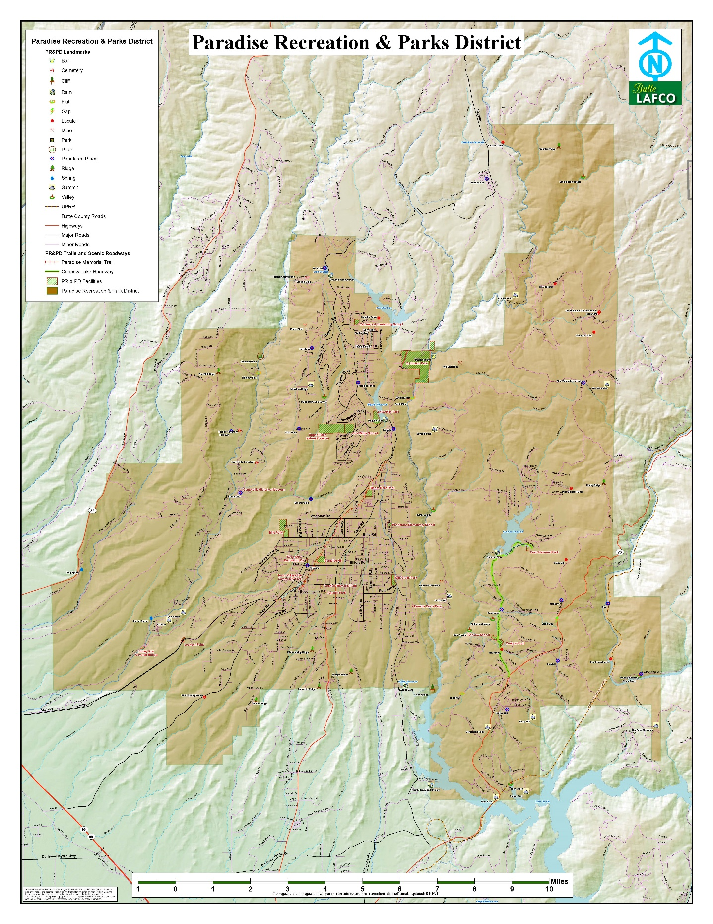

Figure 3. Paradise Recreation and Park District Service Area (Rev. Dec. 2015).

# REFERENCES

[CSCO] California State Controller’s Office. 1976. Special Districts Uniform Accounting and Reporting Procedures. Effective August 1, 1976. Sacramento, California.

Foothill Associates. 2010. Paradise Recreation and Park District, Master Plan Update, 2010-2020. August 2010. Rocklin, California.

O:\Finance\Budget\2019-2020\2019-20.Budget.Report\2019-20.Budget.Report.Final.19.0702.docx

Last printed 8/8/2019 3:32 PM