Field Trip and Excursion Prep
 | Date: | 3/2/2023
 | To: | Administrators, Student Participants, Guardians
 | From: | Scott Amick, Recreation Supervisor
 | CC:
 | Subject: | Field Trip Preparation

Context: Through the Outdoor Education for All initiative titled Healing Trauma Through Nature, Paradise Recreation and Park District has designed a series of outdoor and nature-based adventure experiences which will introduce students to interesting sites, parks, trails, waterways, careers, and downright FUN curriculum. These experiences will challenge the students to prepare for the elements, grit through ill preparedness, and will offer opportunities for personal growth and reflection.
Branding: Paradise Recreation and Park District joins forces Butte County Office of Education and the Chico State Forest Therapy Program for this field trip series. Utilizing classic imagery, such as the traditional Wagon Wheel(see fig 1), and clinically proven therapeutic interventions and sensory invitations, staff will collaborate to explore the Character Concept of the excursion through:
- Thematic connection to each of the park sites
  - integration of Character Word woven through all programming
- Leadership Skill development activities
  - teambuilding exercises, social emotional learning exercises, resilience and trauma coping skill development
- Adventure Skill development activities
  - Map reading and orientation basics, trip planning and preparation, site safety assessment skills, site history
- Ecological Literacy curriculum
  - Lite ecological literacy and information briefs(flora and fauna, bark beetles, watershed travel, geology, other cool facts)
Want to know more about the Field Trip Guide/Instructor?(who are we sending our kids into nature with?) Please select this link to view the Field Trip Bio for Scott Amick
Equipment and Supplies:
A big part of these experiences is learning how to prepare for the excursions with the appropriate gear, clothing, and creature comforts. If, at any time, students do not have the resources to acquire any or all of the equipment listed below – let us know! The last thing we want are the students struggling to enjoy these opportunities due to lack of resources.

Here is a short list of the MUST HAVE items:
- Closed toe shoes
  - Boots are best, tough sneakers will work just fine
  - No sandals
- An extra pair of socks
- A hat
  - Preferably with a bill for sun protection
- A water bottle
- A pack or backpack
  - Standard school sized packs are great, no need to OVERPACK for these short excursions
- Several Layers of clothing
  - Layer 1 – Undies, long johns, and t shirts, thermal gloves
  - Layer 2 – Sweatshirt material – works for the lower body as well
  - Layer 3 – A second sweatshirt
  - Layer 4 – Outer Shell that is either waterproof or water repellant, jeans or pants that can handle a little bit of friction, dirt, and scuffing
- Anything that we decide we do not need, once we arrive on site, will be left in a locked vehicle

Here is a list of the creature comfort items that is nice to have, not required:
- More Socks
- Sunscreen – heavy on the zinc
- Lip Balm
- A balaclava or neck sleeve or cotton scarf
- Several layers of gloves
- Sunglasses
- A hiking staff
- Waterproof Boots
- A booty pad, for when we stop and want to sit on the ground
  - A very small piece of waterproof foam, 10 “ x 10 “ is Scott’s personal preference
  - Students can also sit on their packs if they wish – DON’T bring a small folding chair, too heavy!
- Ask questions before assuming that something will either work or won’t work. We have access to scores of second hand outdoor gear that may be the perfect fit for you or your students

Please email samick@paradiseprpd.com for gear questions, suggestions, and inexpensive, local recommendations for outfitting yourself or your students for these excursions.

Below are a list of locations on the Ridge that will be visited during our excursions:
Site: Paradise Lake – Picnic Side
Excursion Theme/Content: Self Care(Planning Ahead)
Site: Paradise Lake – Boat Launch Side
Excursion Theme/Content: Perseverance

On Site Activities:
- Hiking – approximately 4 miles – 2 miles out and back on flat trail
- Photography(cameras provided)
- Drone Flying
- Teambuilding Activities

Site: Table Mountain Trail
Excursion Theme/Content: The Art of the First Impression (eye contact, hand shake, posture, language)

On Site Activities:
- Hiking – approximately 4 miles – 2 miles out and back on moderate incline trail
- Photography(cameras provided)
- Drone Flying
- Nature Journaling
- Teambuilding Activities

Site: Upper Bidwell Park
Excursion Theme/Content: The Art of Conversation (Active Listening Skills)

On Site Activities:
- Hiking – approximately 2 miles – 1 miles out and back on moderate incline trail
- Photography(cameras provided)
- Drone Piloting
- Nature Journaling
- Rock Climbing and Rappelling

Site: Big Chico Creek Ecological Reserve
Excursion Theme/Content: Kindness, Connection to land

On Site Activities:
- Hiking short distance on flat trail
- Photography(cameras provided)
- Drone Piloting
- Binocular based Bird Watching and identification
- Fire Wise Curriculum

Site: Several – Idea Fab Lab in Chico Ca, Butte College Maker Space
Excursion Theme/Content: Self Confidence
On Site Activities:
- Technology Integration to Outdoor Experiences
- Mapping, Orienteering with GPS
- Trip Planning and Logistics
- Hands on Topography with lasers

Site: Weather Dependent – Either Lil Falls Trail in Magalia OR Lake Oroville Dam Trail
Excursion Theme/Content: Sensory Tuning aka: Investing Attention vs PAYING Attention

On Site Activities:
- Traditional Survival Techniques – Bow Drills, searching and finding water, nutrition in the wild, finding a safe place during the night
- Drone Piloting
- Photography
- Nature Journaling
- Hiking on moderate incline and decline
- Preparing a meal in the wild

Site: The Forebay Aquatic Center
Excursion Theme/Content: Resilience

On Site Activities:
- On the Water Recreation
  - Sailing
  - Rowing
  - Kayaking
- Drone Piloting
- Photography

The Wagon Wheel – A model for the Pioneer Spirit
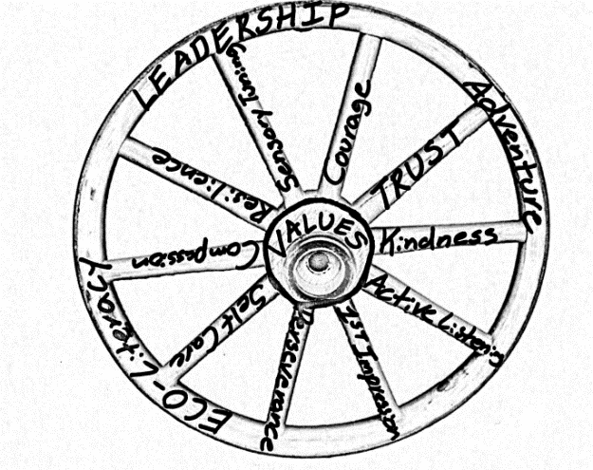

Thematic Narrative
Envisioning the Wagon Wheel in your mind’s eye can conjure up a scene in which a Pioneer sits atop their horse drawn covered wagon, weary with creeks and crackles earned through the challenging path that lies behind, sure to be tested by the unknown travels that lay beyond the horizon. At its core, the wheel is bonded at its hub – the space that holds the whole wheel together. Akin to this analogy, values held in the heart of a person are what hold us together when reflecting on the path behind and preparing for our journey beyond the horizon.

This field trip program aims to utilize the themes expressed as Character Words on the spokes of the wheel to connect core values with life skills. These life skills also tip the hat to the Pioneer(the Wagon Wheel) – Adventure Skill Acquisition, Leadership Skill Development, and Ecological Literacy. Each life skill a pilar in becoming a successful Pioneer, past or present.

Travel
PRPD owns two 10 passenger vans(1 driver, 9 passengers) that will be available to transport the participants to and from the field trip sites.

Each of the sites is within 45 minutes travel from Oroville, which is convenient when considering that the excursion must exist within the standard school day. Systematized travel routines will be implemented in order to ensure that the maximum amount of ADVENTURE time is experienced by the student participants. Digital directions from Google Maps have been provided for each site(select the blue Directions option on the Travel line detail above).

Parent Chaperones
Welcome! Though Parent Chaperones must drive themselves, upon arrival to the field trip site, staff will consider them an equal part of the experience with expectations including a “choose your adventure level” conversation with staff leadership. This short conversation is an expectation management opportunity in which staff explain our participation philosophy.

Challenge by Choice
Staff and volunteers are here to create a space for students to explore themes, nature, and healing growth opportunities. We are not here to force anyone to do anything that they do not want to do. We encourage you to lead by example and to give yourself permission to share your courage, knowledge, perspective, and heartfelt gratitude with your fellow participants. As with every other participant, staff reserve the right to address inappropriate behavior in accordance with the severity of the transgression. Examples include, but are not limited to; side conversations, sitting out, leaving the field trip site early, reporting behavior to school site administration, involving law enforcement.

Accommodations
Persons with disabilities or special needs are encouraged to reach out to PRPD staff prior to the scheduled field trip to discuss best practices, accommodations, and program flow. PRPD communicates closely with community partners that provide resources for persons with disabilities. Through partnerships with Butte County Office of Education, Chico State Adapted Physical Education Department, Ability First Sports, and Butte County Public Health, skilled personnel, adapted adventure equipment, and site modification are readily available resources that ensure maximum participation opportunity is always present.

Activity Level
Each field trip site will require a different level of physical exertion. At NO POINT will participants be encouraged to run or move quickly. To stay true to the Wagon Wheel, which is not built for speed, we will cruise through each of the field trips at a slow to moderate pace. Most of the activity will be hiking with a lite pack, walking on trails or paved surfaces, or engaging in teambuilding activities.

Expense Detail
PRPD and BCOE have worked diligently to bring these field trips to the students free of charge. This includes lunches and snacks, equipment rentals, technology, parking fees, and a host of other expenses. At this point, we do not see any expenses for the participants or their families.

